

REFLECTIONS
2026

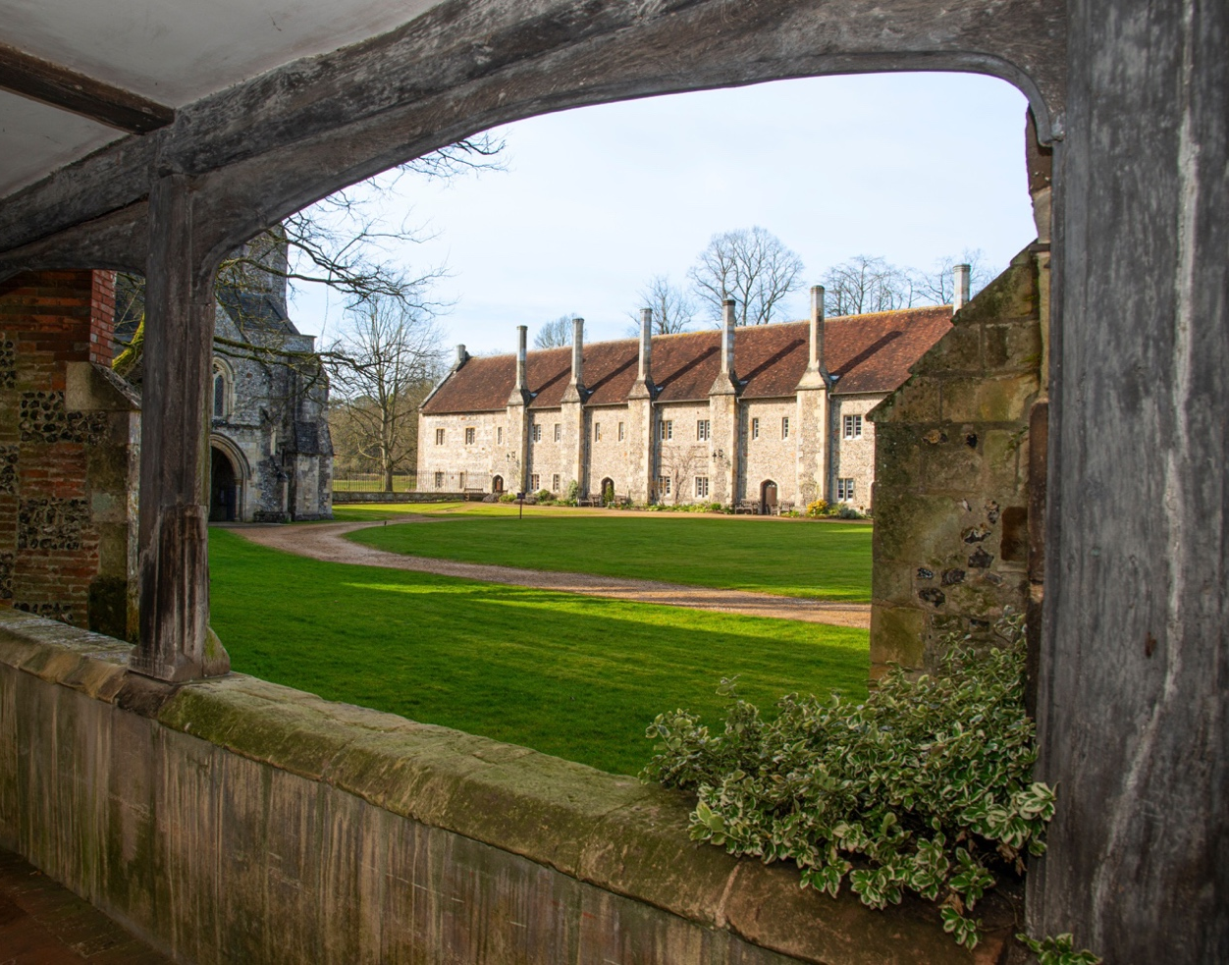

Photograph kindly donated by Peter Dawes (peterdawesphotography@gmail.com)

Welcome to all Friends of St Cross Hospital to the latest edition of Reflections. There has been so much happening this year it’s been good to look back. We are also very grateful to all those who have contributed to the magazine. I hope you enjoy reading about them.

WELCOME NOTE FROM JOHN PRINGLE

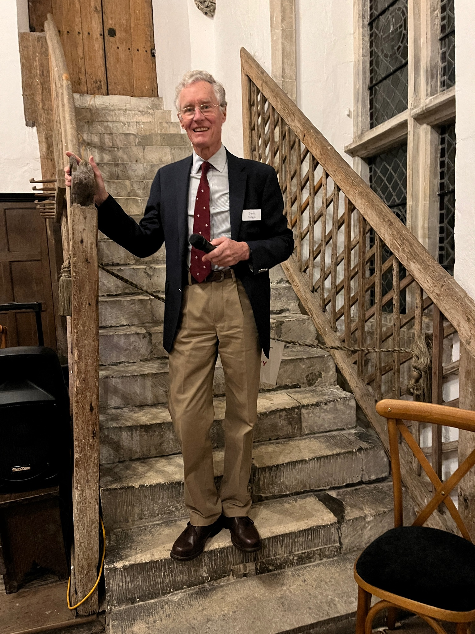

At the Friends AGM on May 15th, in accordance with our Constitution, I will step down as a Trustee, and therefore as Chairman. After 15 years as a Trustee and 10 as Chairman, it feels like the right time to make space for others to be involved in the governance of our charity. Looking back to our beginnings in 2001, I think we can be proud of what has been achieved. From an initial 200 Friends we have grown to over 500 memberships, enabling us to make a real and lasting contribution to the care of the buildings and grounds of the Hospital of St Cross for everyone who lives, works, or visits here.

We have supported many projects over the years, but two have given me particular pleasure: the beautiful restoration of the Chapel’s wooden ceiling, and the access improvements that have made the site more welcoming to all, including the Chapel access route and the lift connecting the Old Kitchen to the Brethren’s Hall. Pip Billington and Fiona Bunnage will jointly take on the role of Chair, subject to approval at the AGM and by the Charity Commission. I will, of course, remain an active Friend and help where I can. Finally, my sincere thanks to my fellow Trustees, the Trustees and staff of the Hospital, and especially Fiona Whitehouse, who works tirelessly behind the scenes — teamwork has truly been the key to our success.

In case you think I will be unemployed twiddling my thumbs at home I assure you my garden will fill any spare time! Evelyn and I may do a bit more travelling too as there are still places we would like to visit before long. And there are always Friends events to attend!

NEW FACES - EMMA PIKE

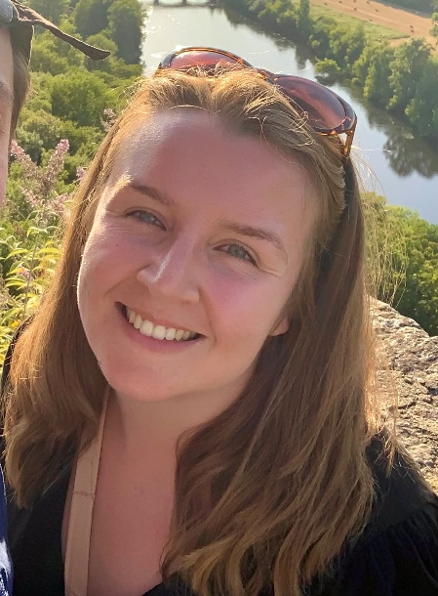

I’m so excited to have joined the Friends of St Cross Hospital Trustee board.

I love spending time at the Hospital and in fact it was visiting the Hospital that was one of the key inspirations for my partner and I moving to Winchester four years ago. It also feels very fitting to be working with St Cross having previously studied medieval almshouses as a History undergraduate at the University of York!

Since then, I’ve developed over a decade of fundraising experience at a range of organisations including the British Lung Foundation and Renewable World. I currently lead an award-winning team of philanthropy operations and events professionals at Marie Curie, responsible for generating over £2 million income annually.

Outside of work I enjoy spending time in the countryside and trying out all sorts of arty activities – my spare time is currently being taken up by trying to learn the art of drawing pet portraits in pastels!

I hope my fundraising experience and passion for preserving our local heritage and love for the Hospital puts me in a strong position to contribute meaningfully to the Friends.

FOSC TRUSTEES

The Friends Board of Trustees at work…

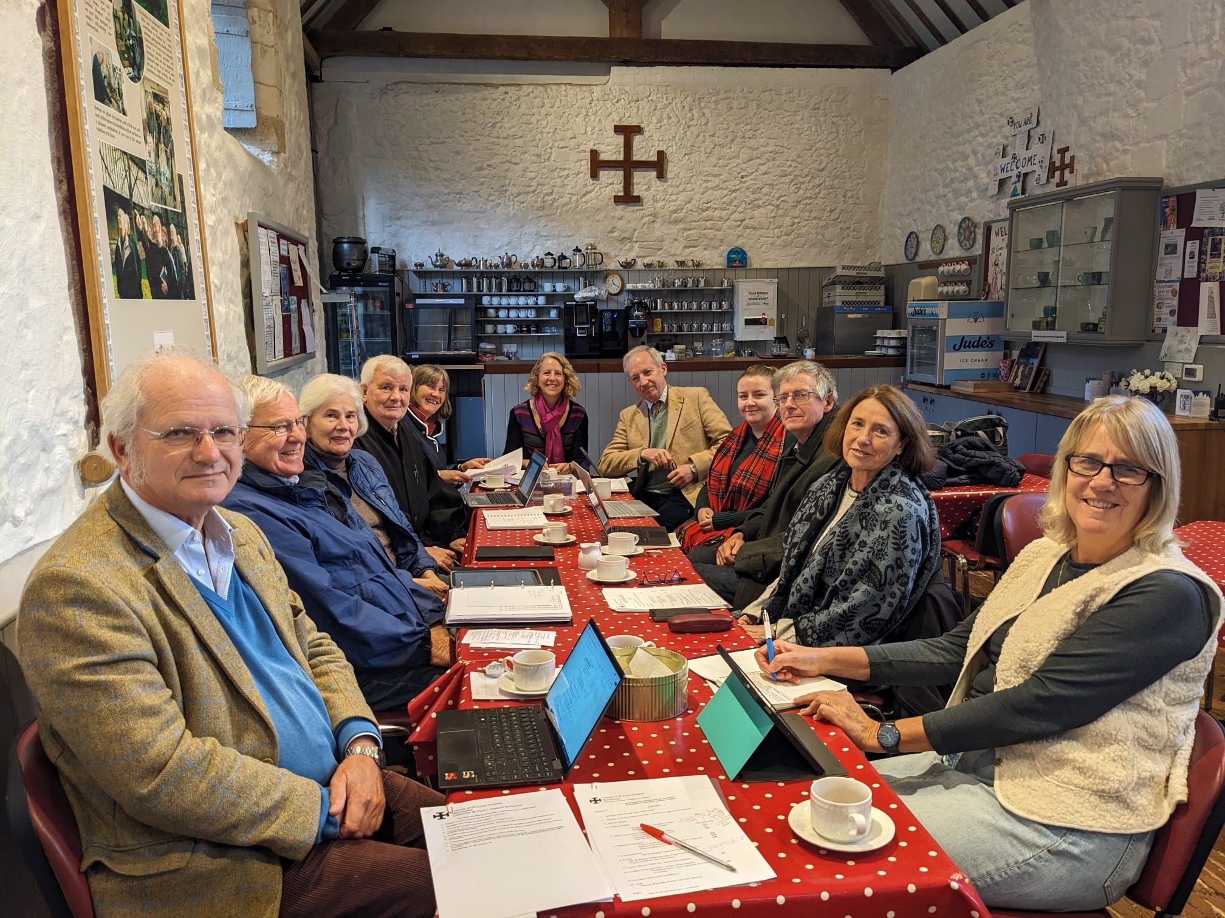
Our Trustees are volunteers who meet four times a year to discuss items such as finance, membership, marketing and administration. There are two committees, one for Finance and one for Marketing, and several subcommittees for specific issues and events. We also liaise closely with the Hospital of St Cross Board to understand what’s needed and how we can help. The Trustees all work hard to bring you a varied and interesting programme each year that raises funds to donate to the Hospital of St Cross. The funds contribute to the maintenance of the fabric of the ancient buildings. We have a great team, all held together by our multi-tasking Administrator, Fiona Whitehouse.

Some of the Board hard at work
SNAPSHOTS OF 2025

New Year Reception

We always start the year with a Reception in the Brethren’s Hall. A thank you to the Friends from the Trustees, with drinks and homemade canapés. A time to socialise and welcome in the New Year.

Burns Night

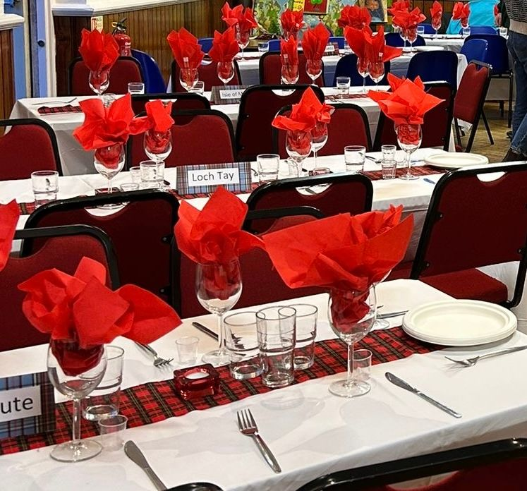
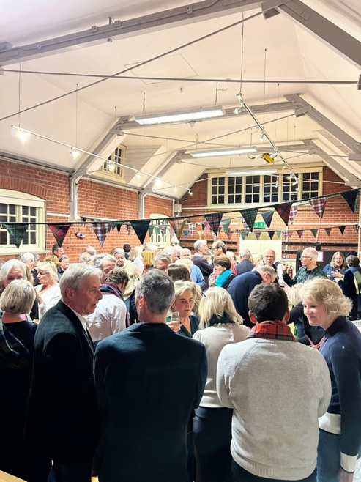
25th January saw the Friends’ biannual Burns Night in St Faith’s Hall. Canapés, haggis piped in and addressed, tatties and neeps, all home cooked, followed by energetic Scottish dancing. A fun evening thanks to the Burns committee, it raised over £2,000.

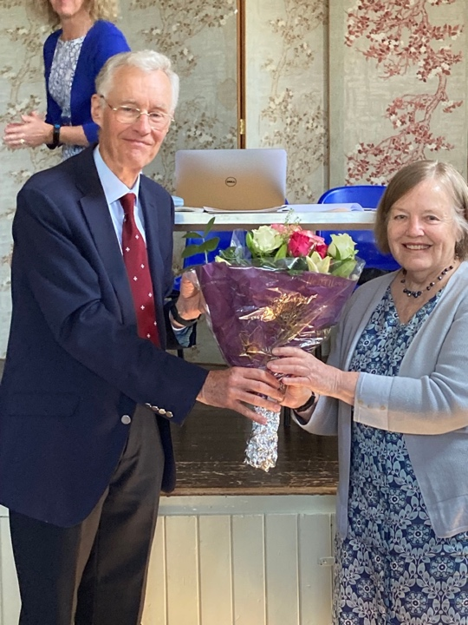

Friends’ Day and Gill's Retirement

Our Friends Day and AGM saw the farewell to long-standing Trustee, Gill Rushton, who single-handedly produced our Retrospective magazine for many years. We thanked her for her service and presented her with a lovely bouquet.

Our usual grant to the Hospital of St Cross amounted to £21,000 this year. A cheque was presented to Jonathan Portal, Chair of St Cross Hospital Board. A great achievement from all the Friends.
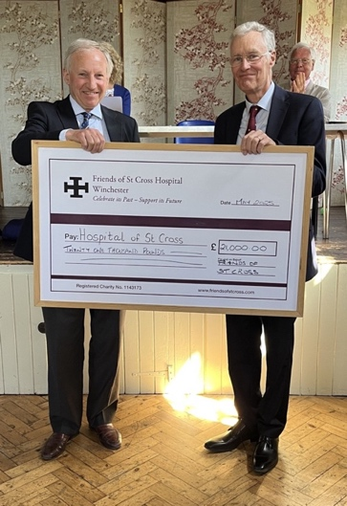

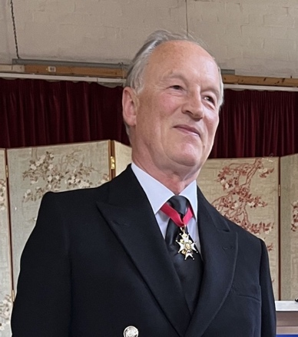
Alastair Bruce, our Patron, had a last-minute dash to Winchester after attending the Tercentenary of the Order of the Bath, established in 1725. Alastair gave us an unexpected brief history of the Order of the Bath, followed by his experiences as a Sky and ABC news reporter of the election of the new Pope. Situated on a rooftop by the Vatican he had a wonderful view of the splendour and pageantry of the event and was able to tell us the election process in great detail. A group of nearby seagull chicks helped him pass the time while waiting for the results and were fascinated by the white smoke.

We were blessed with a beautiful hot summer's day to partake of the usual afternoon tea in the Master’s Garden.
Summer Party

Another highlight was the Summer Party in June. Music with picnics in the Master’s Garden was enjoyed by over two hundred people. Always a popular event, showing off the beautiful grounds of St Cross Hospital to best effect, it is major contributor to our fund raising. This year raised an absolutely fantastic amount of over £8,000! Thank you to the Party committee.
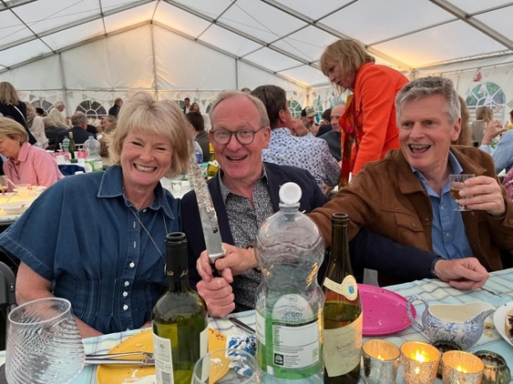
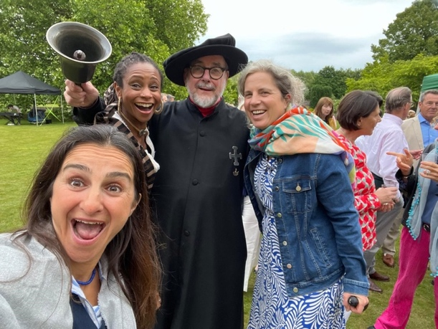
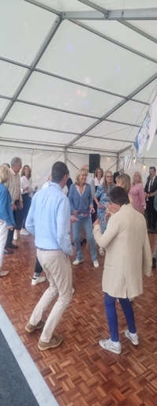

The Variety Show

The Variety Show in November, also happens every two years. Local talent brought together for an evening of music, singing, recitations and sketches. This year was no different, we are very lucky to have such incredible musicians and singers in Winchester.

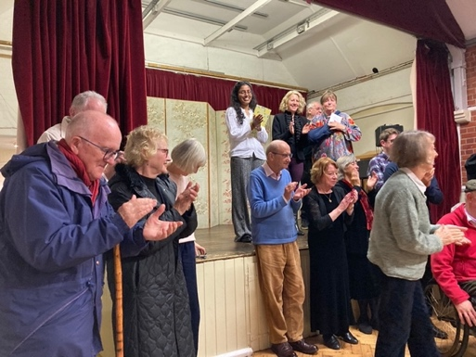

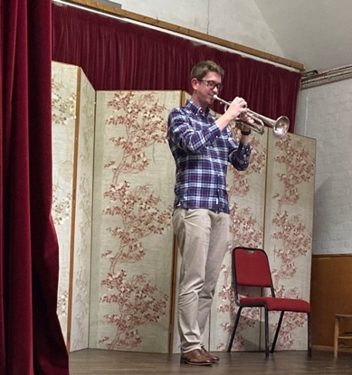

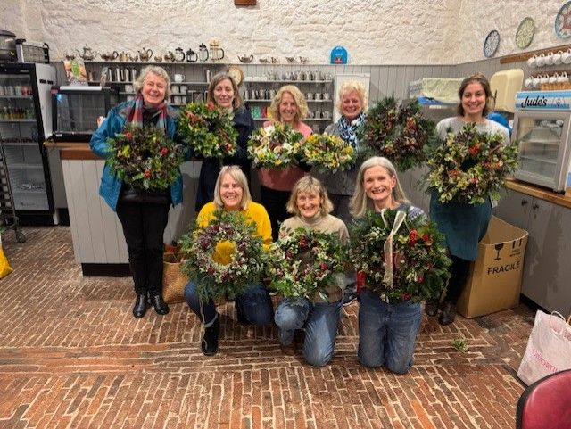
Wreath Making
The traditional Christmas wreath making was held in early December. Our own Fiona Whitehouse led the group. The basics of wreath making were provided and makers brought their own foliage and decorations resulting in wonderful and very individual garlands. All fortified by Prosecco and mince pies.

Lectures

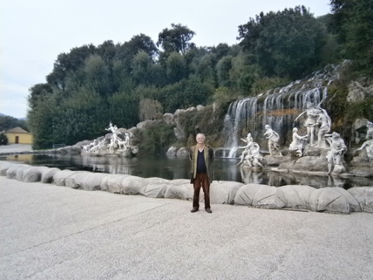

Lectures this year included local interest about “Parchment Street and St Peter’s Street”, Europe with the “Art of Naples”, history with the “Infamous 4th Crusade” and animals with “It shouldn’t have happened to a vet”. All were well attended and very much enjoyed.

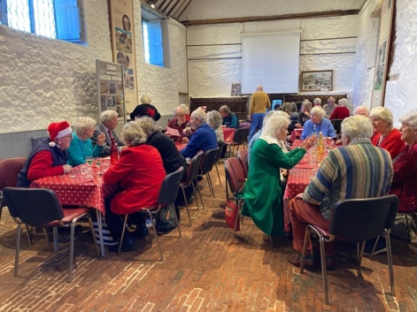
Winter Lunches
The winter lunches in the Hundred Men’s Hall are still proving very popular. Cooked by Friends for Friends, we’ve enjoyed meals of gammon with dauphinoise potatoes, navarin of lamb with buttered leeks and desserts of apple and blackberry crumble and apple cake with cream for example. We endeavour to bring you delicious food so do come and join us if you haven’t already.
Meet Lorraine: The Hospital’s New Chef

Tucked away in one corner of the Hospital of St Cross is a small kitchen where the Brothers can have a two-course lunch each day. It’s easy to miss if you’re passing through but it’s an important part of daily life for the community. Since August, the meals have been prepared by the Hospital’s new chef, Lorraine.
Lorraine began her career straight from school, studying silver-service waitressing and catering at Cricklade College in Andover. From there she worked in a mixture of military and civilian kitchens, gaining experience in busy, structured environments where everything has to run on time.
After many years in fast-paced catering, Lorraine felt ready for a change. When she saw the post advertised at St Cross, she felt the slower pace and smaller scale would suit her well. “Who could ask for a nicer place to work?” she says. “It’s a lovely setting, and cooking for just twenty-five Brothers means you can take a more personal approach.”
Not all the Brothers come for lunch every day, so she sees different people throughout the week. She enjoys getting to know them, taking requests where possible, and hearing which meals they particularly like. Lamb’s liver and bacon is a regular favourite. “An empty plate is the best compliment,” she says. “It tells you everything you need to know.”
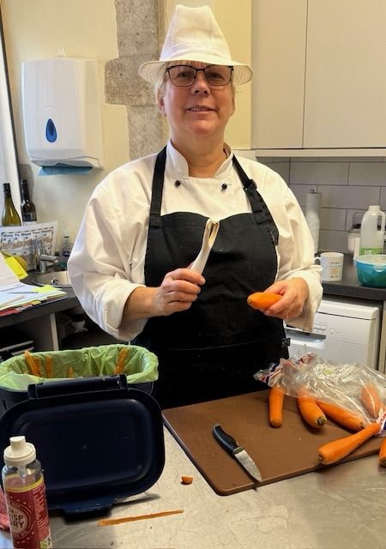
Each week begins with planning the menus and sourcing fresh ingredients. Lorraine prefers keeping things straightforward and well-balanced, with familiar dishes cooked properly. When available, she also likes to use fresh vegetables and fruit from the Brothers’ own garden, adding a local, seasonal touch to her meals.
When there’s a quiet moment, she often pauses at the kitchen door and looks out onto the inner quad. The buildings and the slower pace of the place are something she appreciates. “It’s a calm environment to work in,” she says.
For Lorraine, cooking at St Cross feels a bit like cooking for a large extended family. “You want them to enjoy their meal,” she says. “You cook with care.”
As she continues settling into her role, she hopes to keep offering meals that are simple, good quality and enjoyed by the brothers — a practical, everyday contribution to life at the Hospital.
Behind and in front of the curtains ...... the Variety Show by Dodie Mowat

Every two years, Cathy organises a Friends Variety Show — a time to realise what talent we have within our community, the congregation, the brothers, and even wider afield.
I have been asked to do what has now become “Dodie’s Ditties.” These fill the gaps between acts and allow time for scene changes and so on. In the past there were usually about six items, but when I checked with Cathy this year, she said I needed eleven, as there were twelve acts. “Oh,” I thought, “help — can I find that many? I may have to use repeats.” Cathy said, “You wouldn’t remember — I hope you didn’t!”
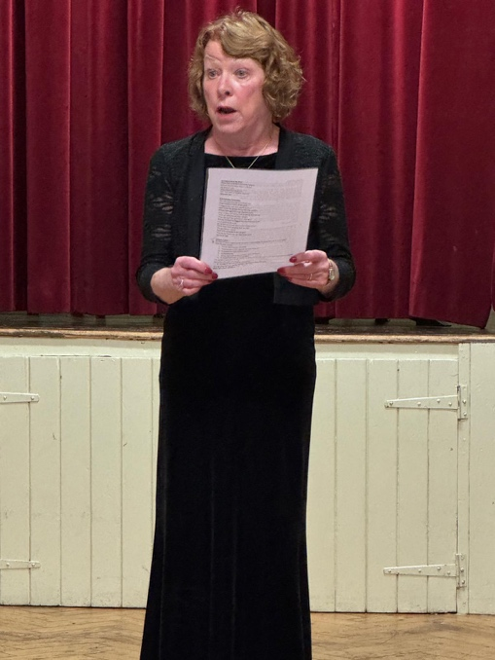
Well, those of you who know me — or even those who don’t — may not realise how nervous I get. Although I have been used to performing all my life, nervous I certainly was. But once I got going, I was alright.
My material has been collected over the years, mainly on cruise ships. They often gathered jokes and anecdotes into small books to sell for worthy causes, and that’s where many of mine came from.
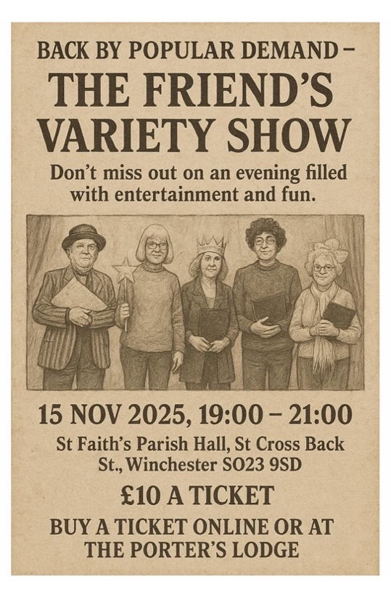
Everything seemed to go well. The audience laughed in the right places, and in the second half — after a glass of wine — I even managed to perform my ditty about the snake who hissed in the pit… without making sure he only hissed in the pit! I look forward to many more of these concerts — celebrating talent, having fun, and raising funds. Meanwhile, I will continue to hunt for my ditties. If you come across any, please do let me know.
Dodie

Eileen - a Volunteer in the HMH Cafe

Born in the north of England, I have lived and worked in many places, here and abroad. From working in a big modern trauma hospital in New Zealand to under trees in makeshift ‘clinics’ of South Sudan with no facilities; maybe that’s where I had a taste of volunteering? We vaccinated hundreds of babies against measles and polio and trained to prevent and treat diseases and injuries. I returned 5 years later and seeing the change was wonderful. Still no running water though!

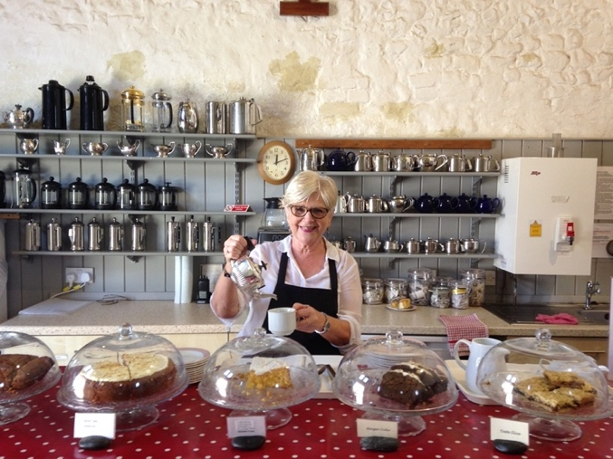
I worked in the NHS for 50 years, starting as a very naïve 17-year-old cadet and retired at 67 as lead nurse. I was an Anaesthetic nurse in Theatres but my most exciting job has been as a Practice Nurse for 20 years at St Paul’s surgery, much more hands on and diverse. I never worked a day in my life.

I have a wonderful family and I was looking forward to retiring but I had bumped into an ex-patient from the surgery, who ran the Tearoom then, and had heard I was retiring. She convinced me to join. I could choose when I work, a luxury you didn’t get in the NHS. So, thank you Janet for your very persistent nature.

We all love working at the Tearoom, I work Thursday mornings with Juliet and Ann. We threesome have helped out on many occasions: Brothers 90th birthdays, church concerts and Michaelmas fairs. It is so rewarding and people are so grateful. It’s Concert Day so can be really busy, but nothing quite like doing a night shift in an inner-city hospital in A&E of course.

We have lovely visitors, walking groups, concert goers, curious passers-by who we invite in. It has its quiet moments, people sitting the garden, contemplating life or reading a book, some want to chat, some not. The pre-Concert goers like to try our cakes and speciality coffees then the post-Concert group arrive looking for the hot pasties and sausage rolls. We have such a good relationship with them, especially the regulars. It’s the best part of the job.

Covid of course closed the Tearoom but I came out of retirement to vaccinate the public with my old colleagues. I may have retired from nursing but I haven’t retired from people or from being busy. St Cross has shown me that retirement isn’t about slowing down - it’s about finding new ways to give, connect and belong. Everyone at St Cross is wonderful.

THE BROTHERS' GARDEN

Stillness in Movement

Over the years I’ve heard many names for used for the private part of St Cross that sits behind the Brothers’ apartments. “The Secret Garden”, the “Hidden Garden”, the “Enclosure”, the “Allotments”….. Like many aspects of The Hospital of St Cross, this garden continues to evolve yet remains very much the same.

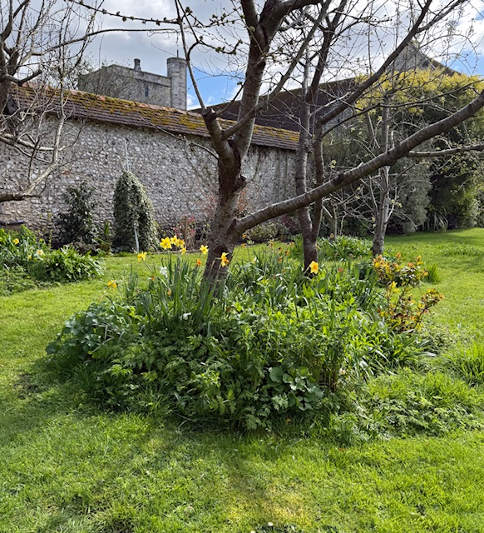
Rooms at the rear of the apartments look on to this garden, over the lockburn that runs around the back of the buildings, in times past servicing the garderobes.

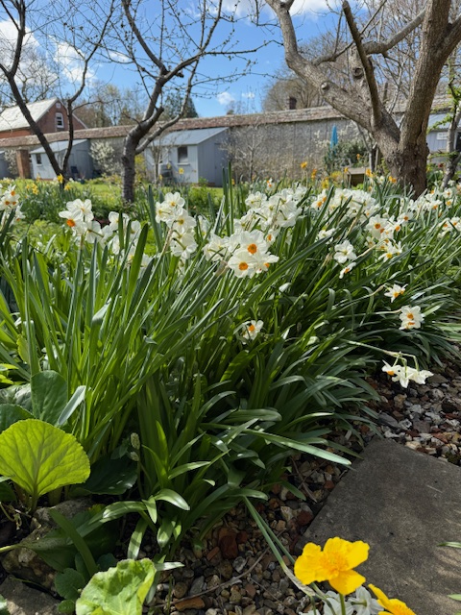
Today, the occasional egret, and if you are very quiet, a kingfisher can be spotted visiting the lockburn which flows into the gardens from the Water Meadows, returning via the Park. The Brothers’ garden acts as a haven for a family of wayfaring partridges that is known to nest in its quiet corners. Some years there can be as many as thirteen chicks hatched and they are well skilled in using “the tunnel” to explore both the private and public parts of St Cross. There is also an owl that makes night time visits to the garden, calling from its perch on the post of the washing line. Less friendly visitors are the jackdaws that gather twigs and squabble over nesting positions whilst their fledglings dive bomb anyone passing by.

Nothing here echoes the order of the Master’s Garden. No manicured lawn or flower beds carefully tended. No weeded gravel paths or carp hoping to be fed. The Brothers’ garden is very much a world of its own. As one visitor put it “it’s reminiscent of a scene from a Thomas Hardy novel”.

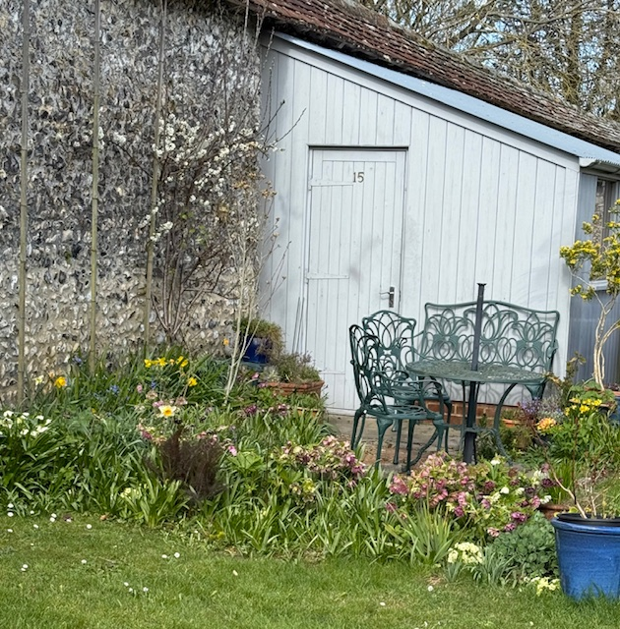
Fruit trees of varying ages set the main theme and as the season’s roll, a parade of flowers add to the look that speaks more of tended nature than of orderly, organised gardening. Hellebores, snowdrops, violets, primroses, foxgloves and old roses rub shoulders with clumps of nettles that offer butterflies space to lay their eggs and provide caterpillars with food. Bee orchids, cowslips, St John’s Lace, oxeye daisies, meadow cranesbill, evening primrose, teasels and red campion find homes amongst the grasses of the “no mow May” mini meadows. In earlier days the entire garden was given over to allotment beds, providing vegetables for the table. Today just a small area continues that tradition with four raised beds, a soft fruit area, a small mixed vegetable bed and a greenhouse used for propagating tomatoes during the summer.
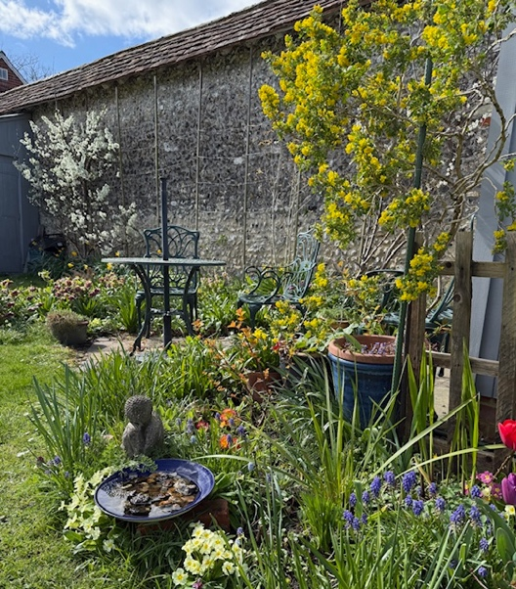

Above all the garden is a place of calm, escape, stillness, where everything is valued and space is made that offers an inclusive environment and the possibility of working alongside nature rather than seeking to control it.

A lesson worth learning as we see life in the Hospital of St Cross changing even when things appear to stay the same.

The Chapel of St Cross Tower Tour
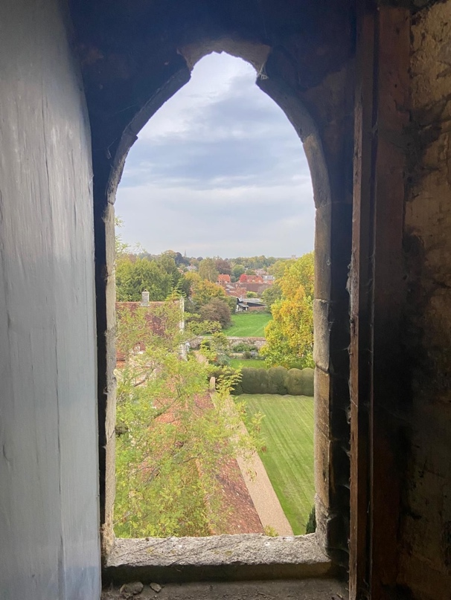
If you’re looking for a truly memorable experience in Winchester, I highly recommend booking a place on one of the Tower Tours of the chapel at the Hospital of St Cross. Without giving too much away, this tour offers all the intrigue of the Cathedral Tower climb—without the sense of claustrophobia—and every bit as much fascination.
A small group of us ascended the spiral staircase in the north-eastern corner of the chapel. Catherine Secker, who usually leads the tour, was unavailable that day, so the tour was led by led by Jonathan Sleath, with his wife Lysbeth following close behind. She managed the lighting and locks, carrying a large torch to illuminate hidden corners and points of architectural interest and her knowledge and enthusiasm for Trollope was enough to make me start the Barchester Chronicles as soon as I got home.
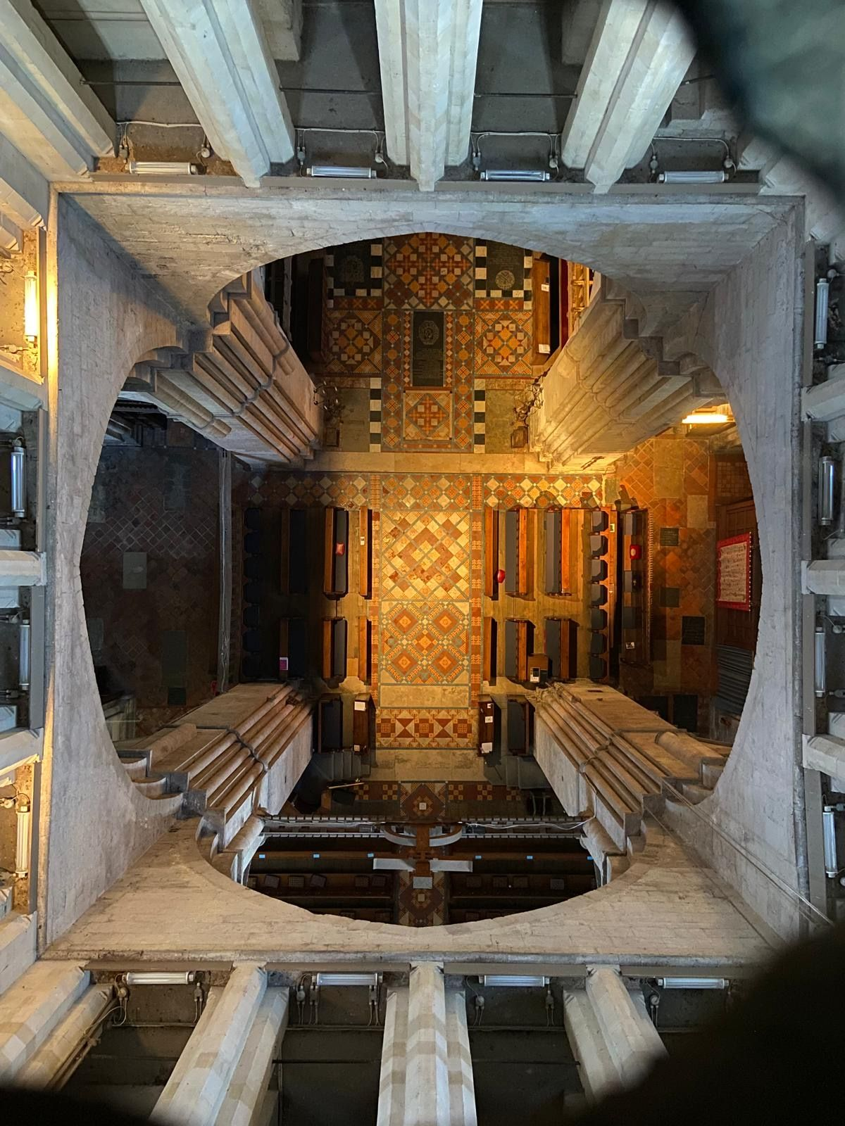
The tour provides a remarkable insight into both the construction of the chapel and its changing use over the centuries. The first stop is a room above the porch—its exact purpose long lost to history. It’s thought that the chaplain may have stayed there overnight, ready to attend to an ailing Brother if needed. (Thankfully, Father Dominik isn’t expected to do that these days)
Throughout the climb, fascinating graffiti and mason’s marks invite speculation—so bring a torch to fully appreciate them. One particularly atmospheric space is believed to have been used by medieval scribes, whose quiet work once filled the room with the scratch of quills on parchment.
Many distinguished visitors have passed through St Cross over the centuries. Did you know that Philip of Spain slept in the room above the Beaufort Tower the night before he married Mary Tudor in Winchester Cathedral?
As the tour winds upward, you’re treated to rare views of the vaulted arches above the nave and transepts. The guides explain the clever fire-prevention and drainage systems designed to protect the vaults—ingenious features that reveal the medieval builders’ mastery of both art and engineering.
The stairways are steep and narrow, so a steady step and sensible shoes are essential. From above, the views down into the church are magnificent, and the guides bring history to life with vivid stories—including the memorable evacuation of Catherine Secker from the bell tower by the local fire brigade. (She claimed she was left dangling halfway down while they dashed off to another call—I believed every word!)
Happily, according to Catherine, there are no unfriendly spirits in the tower—only cheerful ghosts keeping watch over centuries of worship.
* * * * *
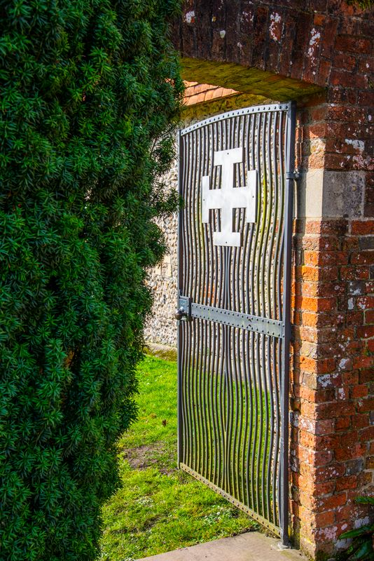

2025 saw a continued growth in membership and we thank you for your continued support. Please let us have your feedback and ideas so that we may provide the type of information and events you would like to have.
Email: friends@stcrosshospital.co.uk

OUR SPONSORS:



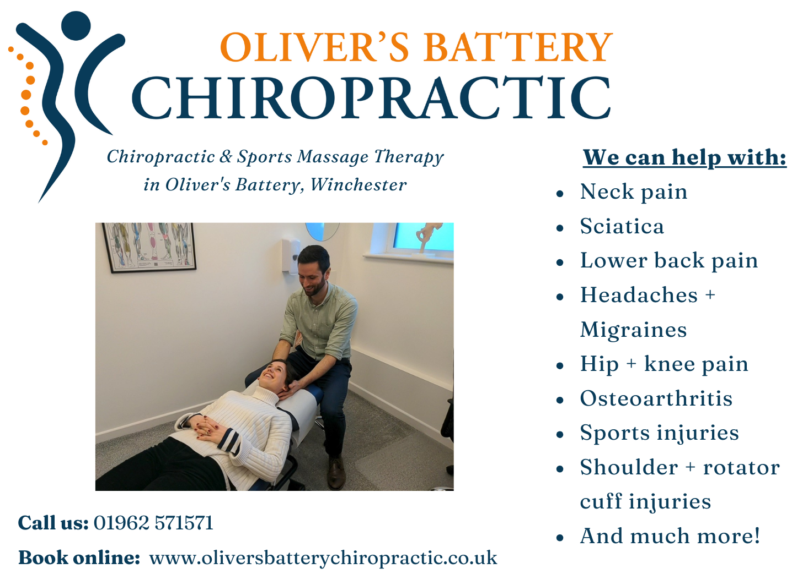

Editors: Lesley Loughridge, Claire McDonnell, Fiona Whitehouse. With grateful thanks to all who have contributed text, photos and editorial comment. © Friends of St Cross Hospital, March 2025. Registered Charity No. 1143173. Contact tel no: 07787 514622 Email: friends@stcrosshospital.co.uk Website: friendsofstcross.com. Correspondence: The Porter's Lodge Office, The Hospital of St Cross, St Cross Rd, Winchester SO23 9SD

